BIRLA INSTITUTE OF TECHNOLOGY AND SCIENCE, PILANI
BIO F242, INTRODUCTION TO BIOINFORMATICS

SECOND SEMESTER 2016 – 2017
MID-SEMESTER EXAM (CLOSED BOOK)
FULL MARKS: 50 DATE: 06.03.17 DURATION: 90 MINS.
- Answer to the point
- Irrelevant and verbose answer may attract penalty
- Steps in each calculation carry marks
1. a) Compare the following pairs: i) PAM and BLOSUM ii) Sequence analysis and Sequence alignment iii) Biomolecular structure through X-ray crystallography and Biomolecular structure through NMR spectroscopy iv) SNP and Point mutation [4X2=8]
b) Which database will you visit for following information (a superficial database will not carry any marks) i) Information related publication of scientific biological literature ii) DNA structure iii) Insulin hormone sequence from horse iv) Splicing information of hemoglobin gene. [2]
2. a) You are using shotgun sequencing to determine the DNA sequence of the genome of this new bacterial species. For one strand of a 30-nucleotide long stretch of DNA, you get the following sequences out of your shotgun sequencing reaction. Assemble the entire 30-nt-long DNA sequence you are trying to sequence, and write the full sequence of the DNA. You only need to write the one strand that is shown; please make sure to label the 5’ and 3’ ends of that one strand. [3]
5’-GGAGTTCCTC-3’
5’-CGCGTTGTCACTGAC-3’
5’-TGGGAGT-3’
5’-TCCTCAAACGCGTTGT-3’
b) Is shotgun sequencing always the best choice for eukaryotic organisms? Why or why not? [1]
d) What would be best method of knowing whether a given program and set of scoring parameters will provide local or global alignment? [2]
3. a) The above two dot plots are for a partial sequence of the cytochrome C oxidase, subunit 1 of Homo sapiens against that of the unicellular dinoflagellate, Alexandrium tamarense in gene and protein level. Window size for both plots is w=12 and colour mapping assigns black to cells where counts for pairwise substring matches are 5 or less. Mention all characteristic features of each plot and compare two plots to infer features of genes and proteins of these two organisms.
[4]

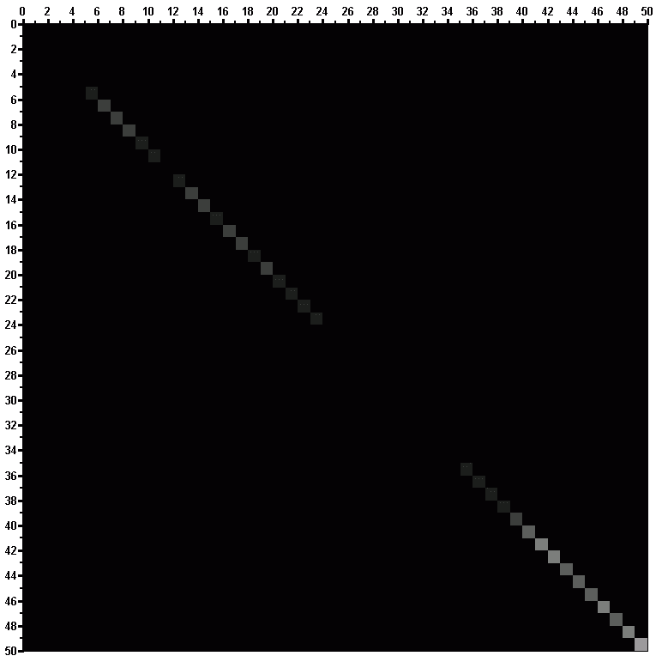

b) Microarray experiment involves harvesting different populations of cells and purifying their RNA, which is then reverse-transcribed into cDNA. The cDNA probes from different populations are then purified and labeled (in various ways) with different fluorochromes (Cy3/Cy5). The probes are then applied to the slide for hybridization to occur. [2+2]
i) While certain researchers extract total RNA from cells to study, others like to extract only messenger RNA. In 20 words or less, why might solely extracting messenger RNA be preferred? ii) Why is it important to use RT (reverse transcriptase) to convert the RNA to cDNA?
c) Single stranded RNA often forms a variety of secondary structures like hairpin turns and DOT PLOT is one of the powerful tools to predict RNA secondary structure. Here is the sequence of one such strand, reading from the 5' end: GGUUCGGGCGAACCUC. Suggest (from DOT PLOT) how this strand might form a hairpin. That is, which bases would pair, and which would be in the turn? [More than one answer may be possible]. [6]

4. a) Justify or criticize following statements with reasons. [2X2=4]
i) From molecular biology and bioinformatics experiments, a Phd student concluded that protein X is 23% homologous to protein Y.
ii) Sequence analysis of myoglobin gene of all mammals revealed 80% identity in protein level and 88% identity in DNA level.
b) While aligning two protein sequences from two unknown organisms a student takes the help of online server. However the student observed that the server provides the option of BLOSUM30, BLOSUM45, BLOSUM50, BLOSUM62, BLOSUM80 and BLOSUM90 scoring scheme. Which one should be used for alignment? Give justification. [Without justification marks will not be awarded]. [3]
c) Why does it observe that the pairwise alignment scores (by DP algorithm) of randomly generated sequences does not follow normal distribution? [2]
d) How does codon bias could be utilized in gene prediction tool? [1]
5. a) Consider a query sequence Q of length L that matches perfectly to a sequence in the database, yielding a E(expectation) -value E1. How would the E-value change if only the first half of Q were searched against the database? In particular, would it stay the same, go up, go down, and how (linearly, exponentially, etc.)? Explain. [3]
b) You decide to explore more commonly used protein alignment scoring matrices. Compare the score (17) for aligning two tryptophans (W) to the score (2) for aligning two alanines (A) in the PAM250 scoring matrix. Both of these alignments are “matches”, so why are these scores so different? [3]
c) Global alignments of the two peptides ATWES and TCAET, using the Needleman-Wunsch algorithm with BLOSUM62 and PAM250 scoring matrix (with linear gap penalty of 2 in both cases) have produced following two alignments. With the help of attached BLOSUM62 and PAM250 scoring matrixes justify the observed differences in alignment. [4]
i) A T W - E S (With BLOSUM62)
- T C A E T

ii) A - T W E S (With PAM250)
T C A - E T

